Assignment 1 - Programming fundamentals

Yueyang Ding

Oct 11, 2022

**Schlacht OF Сталинград**

***Please install the Pillow package please***

***#Python3 -m pip install Pillow***

Background:

During the Second World War, Relations between the Nazis and the Soviet Union were getting worse. Since July 17, 1942, Nazi and Soviet were having a war in the Volgograd called “the battle of Stalingrad”.

Rule of the game:

In this game, you are going to play the role either Nazi or Soviet to win this war. Your goal is to kill all the soldiers from the enemy’s army.

The slogan of Nazi is: My Fuhrer

The slogan of Soviet is: Ypa

This is a war, you can never escape from it. Unless you lose the war.

In this game, you are going to press “r” to roll the dice to decide how many soldiers you killed from the enemy. When you roll a number, the number times your strength and minus the enemy’s defense is your final number to kill the enemy’s soldiers. When you lose all your soldiers, you lose the game. There are three levels in this game, after you win the three levels you will have a little tank model for a prize. If you want to keep playing, you can choose to go to the next round, the second round has three levels as well. The second round’s enemy would be way stronger than the first round. The round is unlimited until you lose. After you lose, you can choose to play the game again or quit the game.

Module:

In my work, there are six files. “App.py, Game.py, Nazi.py, Soviet.py and method.py, image.png”

“App.py” is the main file that imports other modules. It has the introduction of the game, get and play the function from the “Game.py” file. The game should run from this file.

“Game.py” is the module that has all the functions and statements of the game. It does all the calculations and the logic in this model. It also import the function from the file “Nazi.py”, “Soviet.py” and “method.py”.

“Nazi.py” is the module that stores all the Nazi’s(role 1) base data and the text flag of Nazi.

“Soviet.py” is the module that stores all the Soviet’s(role 2) base data and the text flag of Soviet.

“mothod.py” is the module that stores the function that can let two text flags be printed side by side. And a function to text letters one by one is also stored here.

“image.png” is the image that has the welcome on it. I used an image because there is not text art for my russian game name, so I make an image to let player have a better gaming experience.

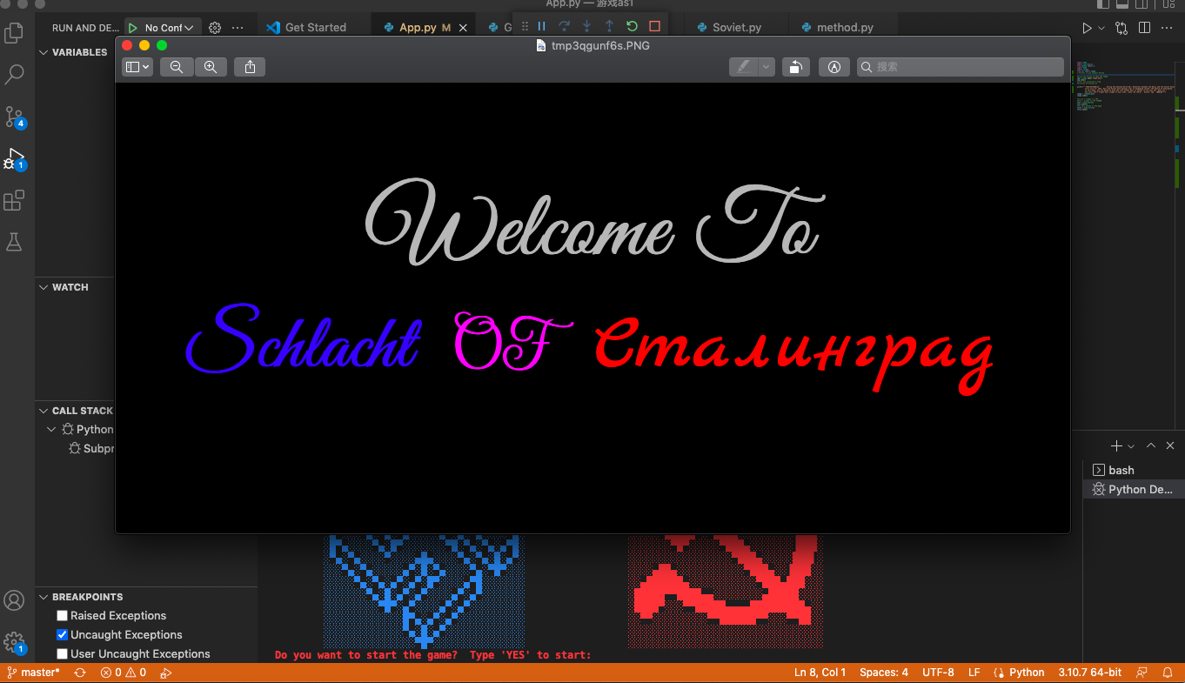

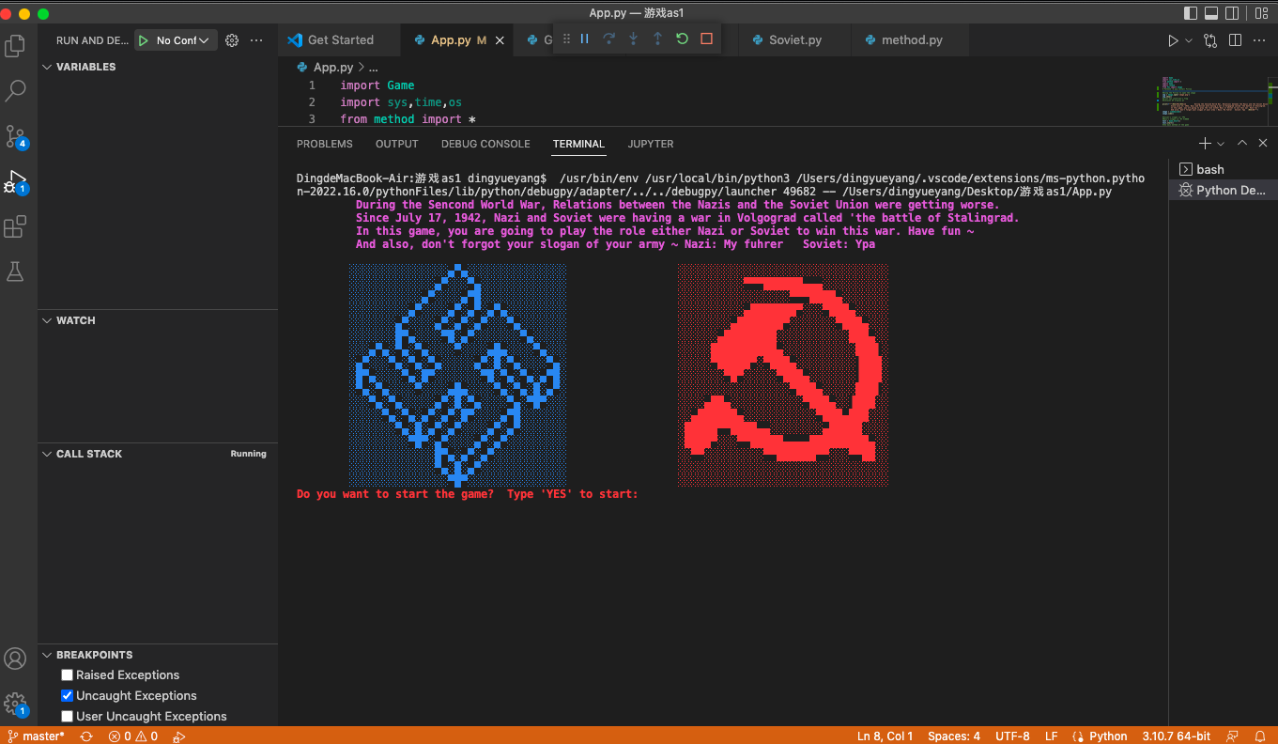

Level 1:

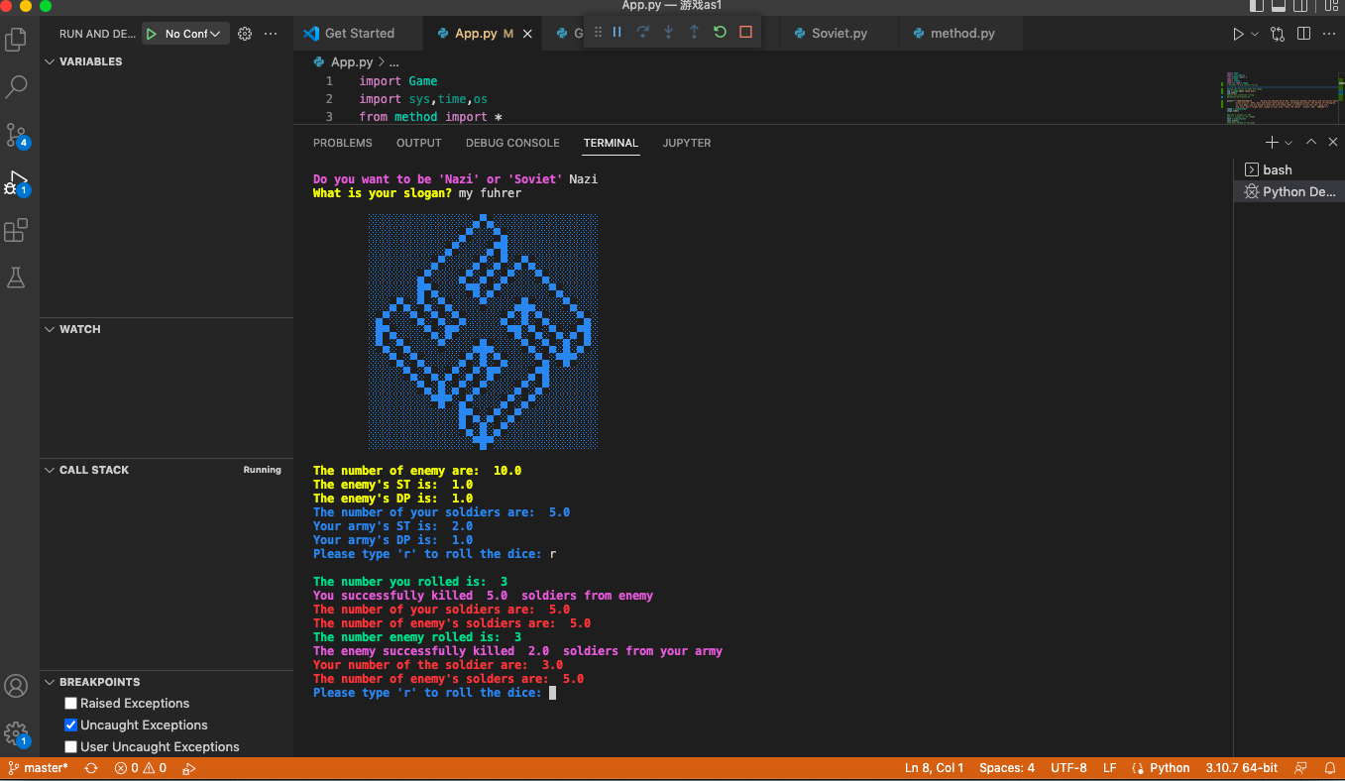

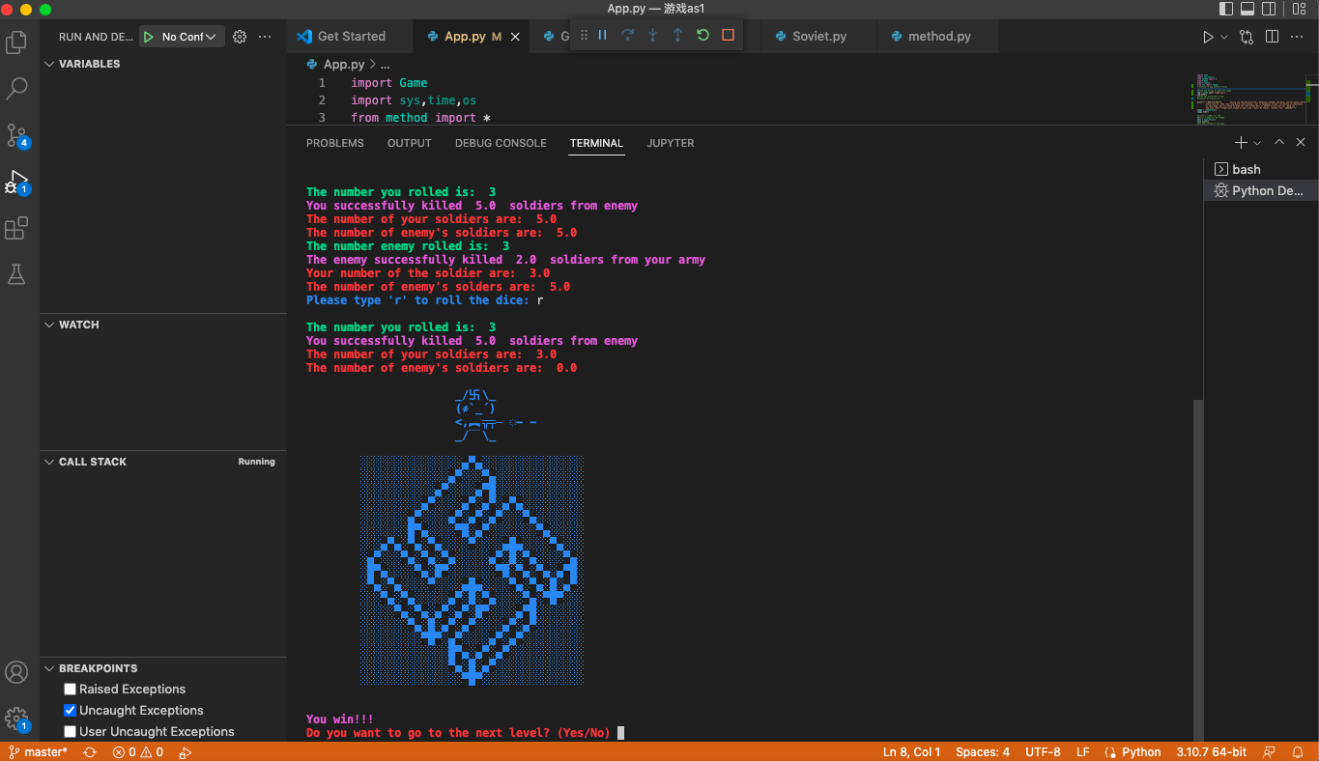

Level 2:

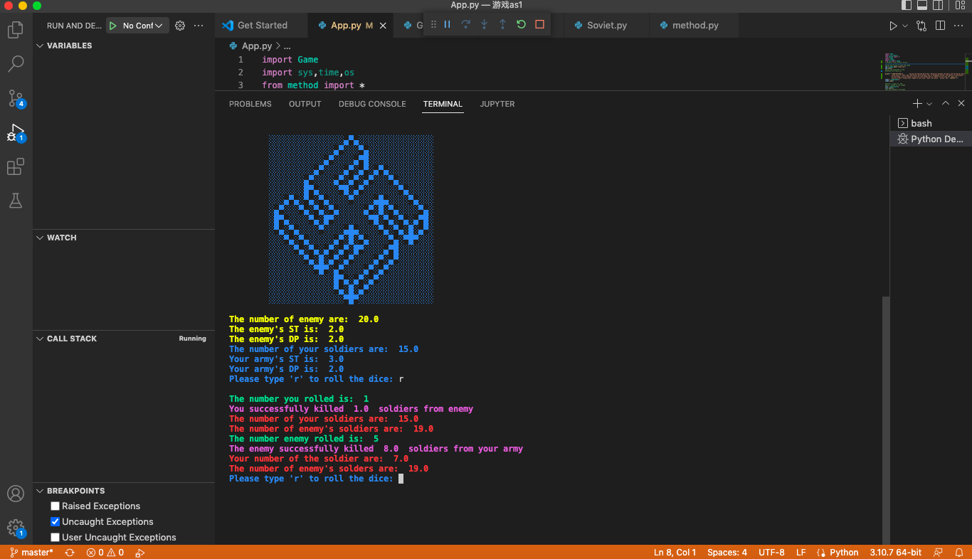

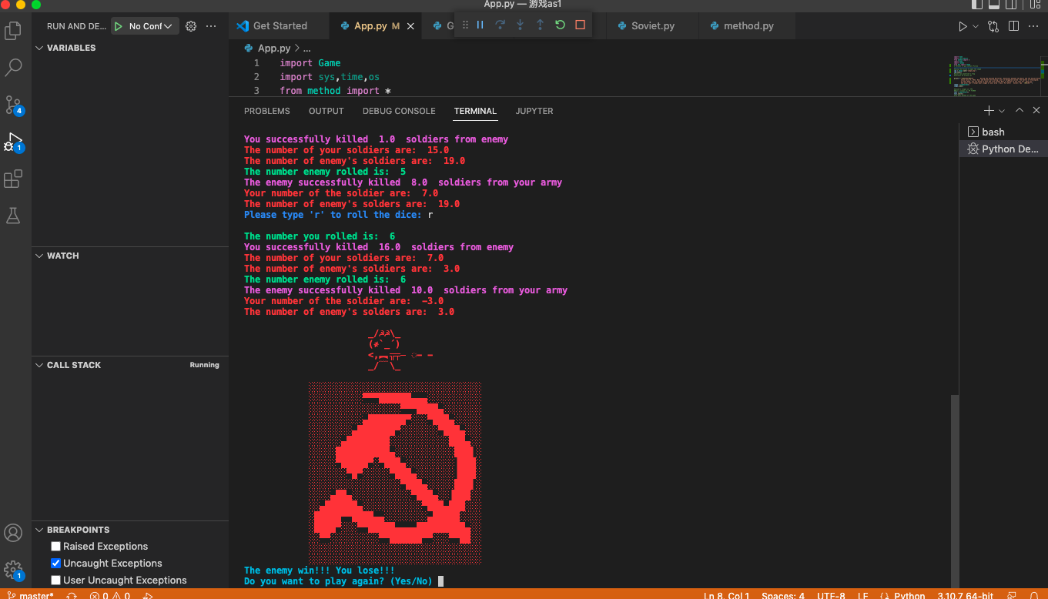

Oh, you lose over here.

When you win the first round(three levels) you got a tank model for prize.

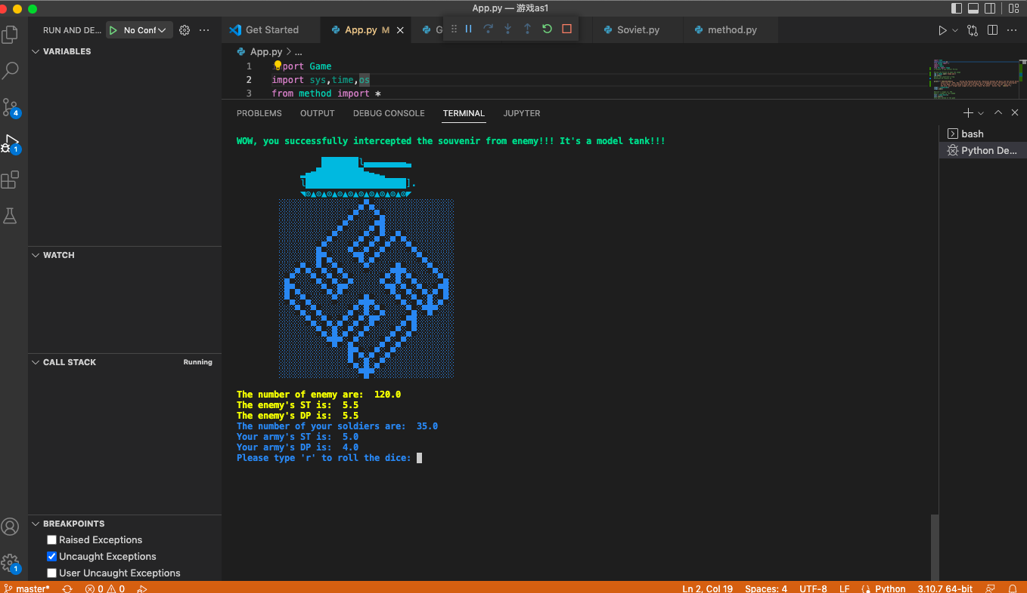

When you lose and don’t want to play again, here you can exit the program.

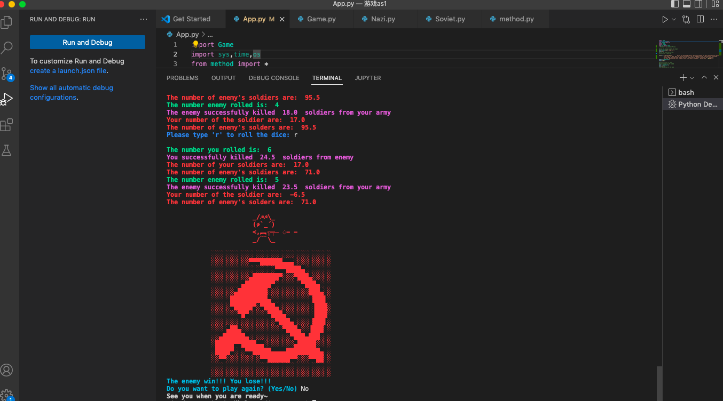

There are some surprises in my game.

Try to type three times “yes” wrong when you enter the game.

Try to type the slogan wrong when you choosing Nazi.

Have fun ~